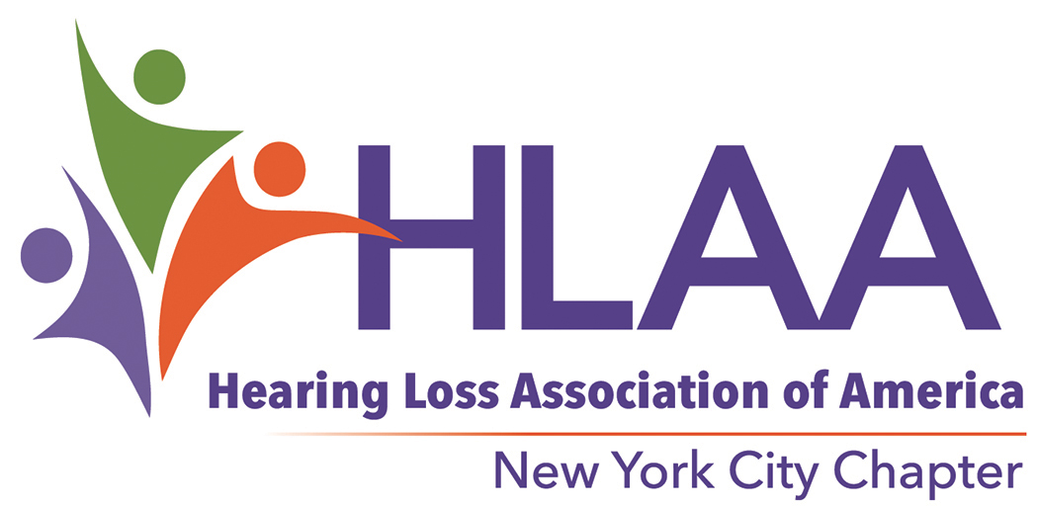

|  |
| --- |
| Hearing Loss Association of America:[www.hearingloss.org/](http://www.hearingloss.org/) ● NYC Chapter: [www.hearinglossnyc.org/](http://www.hearinglossnyc.org/) |

**2024 ANNUAL ALBERT B. CHEN SCHOLARSHIP AWARD  
FOR A HIGH SCHOOL SENIOR WITH HEARING LOSS**

***Applications are time-sensitive. Late submission of materials will disqualify the applicant. Please act on this information as soon as possible. The deadline is April 15, 2024.***

The Hearing Loss Association of America’s New York City Chapter is pleased to announce the Albert B. Chen Scholarship, made possible by funds donated by Albert B. Chen. Mr. Chen, who has a profound hearing loss, hopes to inspire younger generations to give back to the hearing loss community at some point in the future. This $5,000 scholarship for a high school senior with a hearing loss is to be used toward the pursuit of a college degree.

Applicants must be New York City residents, have applied to a college, be between the ages of 17 and 20, wear a hearing aid or cochlear implant, and have a cumulative score of 80 or a grade point average of 3.0 or better. The scholarship is a one-time award for one high school senior. Financial need is not a consideration. The award will be presented at HLAA-NYC's June 18, 2024 chapter meeting, and an ongoing list of winners will be maintained on the HLAA-NYC website.

The Hearing Loss Association of America is the nation’s leading organization representing people with hearing loss and their families. HLAA helps people with hearing loss adjust to living with hearing loss; educates consumers, manufacturers, and policymakers about communications access; works to eradicate the stigma associated with hearing loss; and endeavors to raise public awareness about the importance of regular hearing screenings. The organization has a nationwide network of state organizations and local chapters.

To apply for the scholarship, complete all parts of the 2024 SCHOLARSHIP APPLICATION FORM and send to info@hearinglossnyc.org.

**DEADLINE FOR RECEIPT OF APPLICATIONS: April 15, 2024**

|  |  |  |  |
| --- | --- | --- | --- |
| **Name:** |  | **High School:** |  |
| **2024 SCHOLARSHIP APPLICATION FORM** | | | |
| INSTRUCTIONS: Complete Section I through Section V. Have your two references send their letters as directed in Section VI and on the review checklist (Section VII). | | | |
| Note: Be sure to enter YOUR NAME and the name of your HIGH SCHOOL on each page of this application form, as well as on each page of your essay. | | | |

|  |  |  |  |  |  |  |  |  |  |  |  |  |
| --- | --- | --- | --- | --- | --- | --- | --- | --- | --- | --- | --- | --- |
| **SECTION I: APPLICANT DATA** | | | | | | | | | | | | |
| Name: |  | |  |  | | |  |  | | | | |
|  | (First) | |  | (Middle) | | |  | (Last) | | | | |
| Home address: | |  | | |  |  | | |  |  |  |  | |
|  | | (Street) | | |  | (City) | | |  | (State) |  | (Zip Code) | |

|  |  |  |  |  |  |  |  |  |
| --- | --- | --- | --- | --- | --- | --- | --- | --- |
| Telephone number: |  | | | | | | | |
| Email address: |  | | | | | | | |
| Date of birth: |  | | | | | | | |
| Parent’s or Guardian’s name |  | | | | | | | |
| Parent’s or Guardian’s address: | | | | | | | | |
|  | |  |  | |  |  |  |  | |
| (Street) | |  | (City) | |  | (State) |  | (Zip Code) | |
| Parent’s or Guardian’s daytime telephone number or email: | | | |  | | | | |

|  |  |
| --- | --- |
| **SECTION II: HIGH SCHOOL DATA** | |
| Name(s), address(es) and dates of high school(s) attended: | |
|  | |
|  | |
| Name of most recent high school guidance counselor: |  |
| Guidance counselor’s telephone number: |  |
| Anticipated graduation date: |  |
| Cumulative score or GPA |  |
| ***NOTE****: High School Transcript must be included with your application.* | |

|  |  |  |  |  |  |  |  |  |  |  |  |  |  |  |  |  |  |  |  |  |
| --- | --- | --- | --- | --- | --- | --- | --- | --- | --- | --- | --- | --- | --- | --- | --- | --- | --- | --- | --- | --- |
| **Name:** |  | | | | | | | **High School:** | | | | |  | | | | | | | |
| **SECTION III: COLLEGE OR OTHER POSTSECONDARY SCHOOL DATA** | | | | | | | | | | | | | | | | | |
| Name of college or other postsecondary school for which this scholarship is requested (if undecided, or wait-listed, please indicate the names of the schools): | | | | | | | | | | | | | | | | | |
|  | | | | | | | | | | | | | | | | | |
| Address: | | | | | | | | | | | | | | | | | |
|  | | | |  | | |  | | | |  |  | | |  | |  | |
| (Street) | | | |  | | | (City) | | | |  | (State) | | |  | | (Zip Code) | |
| Please check one: | | 4-year college | | | | 2-year college | | | | Community college | | | | | |  | | | |
| Other (please explain) | | |  | | | | | | | | | | | | | | |
| Acceptance Status: | | Accepted | | | Wait-listed | | | | Undecided | | | | | Don’t know | | | |
| Please attach a copy of your acceptance letter even if you are undecided or wait-listed. If you receive a letter of acceptance after you submit this application, send it to info@hearinglossnyc.org. Use a separate page to list more than one college. | | | | | | | | | | | | | | | | | | | | | |

|  |  |  |  |  |  |  |  |  |  |  |  |  |  |  |  |  |  |  |  |  |  |  |
| --- | --- | --- | --- | --- | --- | --- | --- | --- | --- | --- | --- | --- | --- | --- | --- | --- | --- | --- | --- | --- | --- | --- |
|  |  | | | | | |  | | | | | |  | | | | | | | | | |
| **SECTION IV: AUDIOLOGICAL DATA** | | | | | | | | | | | | | | | | | | | | | | | |
| How would you describe your hearing loss? | | | | | | Mild | | | | | Moderate | | | | Severe | | | | Profound | | |
| At what age was your hearing loss discovered? | | | | | | | | |  | | | | | | | | | | | |
| Do you wear a hearing aid? | | Yes | | No | | | | If Yes: | | | | one | | | or | | two | | | |
| Do you wear a cochlear implant? | | | Yes | | No | | | | | If Yes: | | | | one | | Or | | two | |
| Do you use any accommodations in the classroom, such as note-takers, assistive listening devices, or captioning? If so, please describe and explain: | | | | | | | | | | | | | | | | | | | | |
|  | | | | | | | | | | | | | | | | | | | | |
|  | | | | | | | | | | | | | | | | | | | | |
| Do you use or require assistive listening devices or captioning outside of school, such as captioning for TV or movies? If so, please describe and explain: | | | | | | | | | | | | | | | | | | | | |
|  | | | | | | | | | | | | | | | | | | | | |
|  | | | | | | | | | | | | | | | | | | | | |
| ***NOTE****: Your application must include your most recent audiogram (measured within the last two years) and the audiologist’s report.* | | | | | | | | | | | | | | | | | | | | |

|  |  |  |  |  |
| --- | --- | --- | --- | --- |
| **Name:** |  | **High School:** |  | |
| **SECTION V: ESSAY** | | | |
| Write a 500 to 1000 word essay on the topic of:  **HOW I WOULD IMPROVE ACCESSIBILITY FOR THOSE WITH HEARING LOSS.** | | | |
|  | | | |
| **SECTION VI: LETTERS OF REFERENCE** | | | |
| Two (2) letters of reference are required. One letter must be from a high school teacher or guidance counselor. The second letter can also be from a high school teacher or guidance counselor or can be from an unrelated adult who knows you well, such as a coach, religious leader, scout leader, or employer. Make copies of the last page of this packet and forward those to your references. | | | |
| **Please ask your references to send their letters to** [**info@hearinglossnyc.org**](mailto:info@hearinglossnyc.org) **with the applicant’s name in the subject line. Students will be notified via email when HLAA-NYC receives each letter of reference.** | | | |

|  |  |  |  |  |  |
| --- | --- | --- | --- | --- | --- |
|  | | | | | |
| **Name:** |  | **High School:** |  | | | |
| **SECTION VII: CHECKLIST FOR COMPLETED APPLICATIONS** | | | | |
| SEND YOUR APPLICATION BY OR BEFORE April 15,TO info@hearinglossnyc.org | | | | |
| Include the following: | | | | |
|  | The completed two-page application form. | | |
|  | A copy of your high school transcript. | | |
|  | A copy of your college acceptance letter (even if wait-listed or undecided). | | |
|  | A copy of your most recent audiogram (preferably within the last two years) and audiologist’s report. | | |
|  | Essay as indicated in SECTION V, with your name and the name of your high school at the top of each page. | | |
|  | The signed Publicity Release form (see next page) | | |
|  | Two letters of reference, sent separately, as directed in SECTION VI. | | |
| **All required documents (except letters of reference) must be submitted as attachments in one email by April 15, 2024. Only Word or PDF documents will be accepted. Please do not submit unreadable scans or documents such as Google Docs that require permission to access. It is your responsibility to be sure that documents are readable. Incomplete or missing information will result in your disqualification.** | | | | |

|  |  |  |  |  |  |  |
| --- | --- | --- | --- | --- | --- | --- |
| **Name:** |  | | **High School:** |  | | |
| **PUBLICITY RELEASE** | | | | |
| In exchange for consideration received, I hereby give permission to the Hearing Loss Association of America—New York City Chapter to use my photographs and name in all forms and media for advertising, trade, websites, and all other lawful purposes. | | | | |
| **NAME:** | |  | | | |
| **SIGNATURE:** | |  | | |
| **ADDRESS:** | |  | | |
| **EMAIL:** | |  | | |
| **TELEPHONE:** | |  | | |
| **DATE:** | |  | | |



**LETTER OF REFERENCE FOR SCHOLARSHIP**

***DEADLINE: April 15, 2024***

|  |  |
| --- | --- |
| Applicant’s name and address: |  |
|  |
| Evaluator’s name and address: |  |
|  |
| Relationship of evaluator to applicant (teacher, employer, etc.): |  |
| How long and under what circumstances have you known the applicant? |  |
| Using a *separate* page, please write a letter of reference describing the qualities that you believe will enable the applicant to give back to the hearing-impaired community in the future. | |
| Send this cover sheet and your reference letter to info@hearinglossnyc.org with the applicant’s name in the subject line no later than April 15, 2024, with Albert B. Chen Award in the subject line. If you have any questions, do not hesitate to email info@hearinglossnyc.org | |
| For the Evaluator: Hearing Loss Association of America (HLAA) is a national organization of people with hearing loss, their relatives, and friends. It is a nonprofit, non-sectarian educational organization devoted to the welfare and interests of those who cannot hear well but are committed to participating in the hearing world. | |
| HLAA—New York City Chapter awards one scholarship annually to deserving students with hearing loss who are entering their first year of college. | |
| Thank you for taking the time to complete this evaluation. Your input is very much appreciated. | |
|  | |
|  | |

**Please send your letter to info@hearinglossnyc.org. Students will be notified via email when HLAA-NYC receives each letter of reference. Deadline is April 15, 2024**